DATE:________________

Dear Prospective Employee,

The expense of training and preparing a prospective employee for work is significant. These costs include trainers, compliance filings, testing, clerical work, State and Federal Fees.

As we make this financial commitment to you, we ask that you make the same commitment to us.

Providing we can offer you daily employment, you may be subject to the following provision:

If you should drop out of training or should the relationship with our company end within six months or the end of June for the school year we are currently in– for any reason - you will be responsible for repaying this money back to the company.

Upon request, we will provide you with an itemized list of expenses at the completion of training.

By signing below, you agree to this.

____________________________________
NAME print/sign

____________________________________
WITNESS print/sign

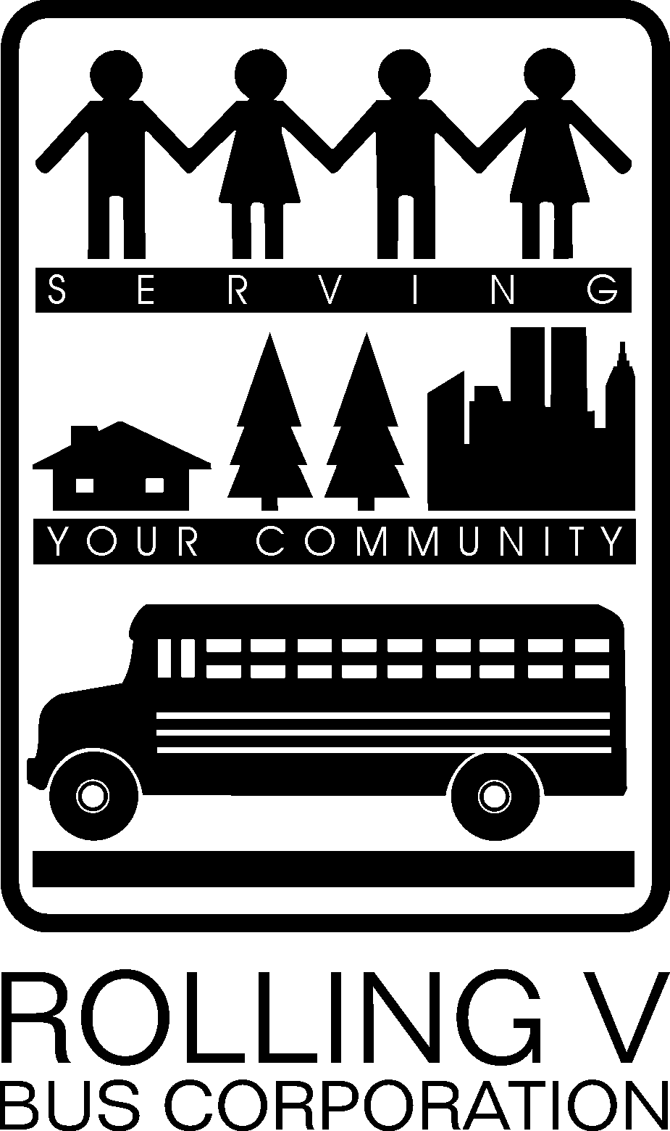
Main Office
Rolling V Bus Corporation
P.O. Box 110
5008 Route 42
South Fallsburg, NY 12779
PHONE:845-434-0511
800-999-6593
FAX:845-434-0259
Email: info@rollingv.com

Liberty Office
Gershowitz Transportation
33 Aden Road
Liberty, NY 12754
PHONE:845-292-4485
800-999-6593
FAX:845-292-0487

Ellenville Office
9 Depot Street
Ellenville, NY 12428
PHONE:845-647-9187
FAX:845-647-7495

Livingston Manor Office
68 School Street
Livingston Manor, NY 12758
PHONE:845-439-3713
FAX:845-439-3823

Neversink Office
Gershowitz Transportation
7444 State Route 55
Neversink, NY 12765
PHONE:845-985-2609
FAX:845-985-0570

Roscoe Office
1 Athletic Field Rd
Roscoe, NY 12776
PHONE:607-498-5888
FAX:607-498-4980

